Holiday Recipes and More
Brussels Sprout Slaw (Brussels Sprouts recipes Inspired by Everyday Food Magazine)
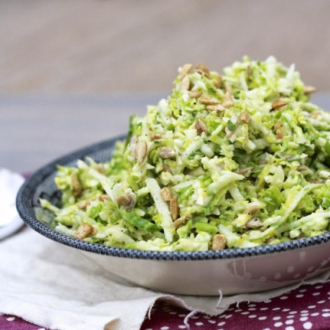
1 Tbsp mustard (we like Country Dijon)
3 Tbsp white-wine vinegar
2 tsp honey
2 tbsp olive oil
Salt and pepper
1 pound of brussels sprouts, trimmed and shredded
1 small head radicchio, cored and thinly sliced
½ cup chopped fresh chives
¼ cup toasted sunflower seeds

Wisk together mustard, vinegar, honey, and oil. Add brussels sprouts, radicchio, chives and sunflower seeds and toss to combine. Salt and Pepper to taste.
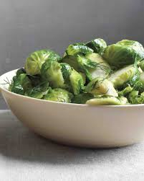

Brussels Sprouts With Dill Butter

1 pound brussels sprouts, trimmed and halved
3 tbsp unsalted butter
¼ cup fresh dill, roughly chopped
Salt and Pepper, Lemon wedges to taste

Boil and salt a pot of water, cook brussels sprouts until tender (about 5 to 6 minutes). Drain thoroughly, toss with butter and dill and season with salt and pepper to taste. Serve with lemon wedges on the side.

Healthy Breakfast Ideas for the morning after a big holiday dinner
(inspired by Farm to Table Magazine)

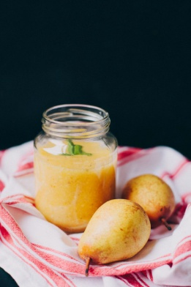
Pear and Mango Smoothie (if you’d like, add other fruits to suit your taste - try raspberries or blueberries)
1 pear
2 cups frozen mango chunks
1 cup pear juice
1 banana
2 tbsp yogurt or kefir
1 tsp chia seeds
1 tsp wheatgrass (totally optional) (recipe continued on next page)

Whipped cream to garnish
½ tsp ground cardamom (also optional)

Peel pear, chop into chunks, then put in blender with frozen mango, pear juice, banana, yogurt and chia seeds (plus any other fruits you venture to add). Blend for about 2 minutes until ingredients are fully blended, and look smooth and creamy. Add the wheatgrass now if you’d like. Pour into glasses and top with whipped cream and a bit of cardamom. Serve with a smile!
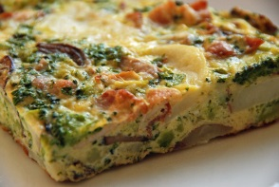

Farmer’s Frittata

4 small red potatoes, scrubbed and quartered 1 medium onion, diced (yields one cup)
1 small head of broccoli, separated into small florets ½ red bell pepper, diced (about ½ cup)
½ lb of ground pork sausage, fresh 1 small Portobello mushroom, diced
1 tsp fresh sage, minced 2 cloves garlic, minced
½ tsp of fresh thyme, minced 6 eggs, lightly beaten
1 tsp smoked paprika salt and pepper to taste
¼ tsp of fine sea salt (sub in regular salt or leave out if desired) 1 cup cheddar (or your favorite) cheese
Pinch of red pepper flakes 1 tbsp chopped fresh herbs, parsley,
1 tbsp olive oil (optional) basil, thyme, tarragon
Steam the potatoes until tender, about 10 minutes, set aside. Steam broccoli for about 5 minutes remove and set aside.

Mix sausage with herbs, salt and pepper and red pepper flakes thoroughly. Cover, refrigerate for 30 minutes (this can be done the night before if you prefer).

Preheat broiler to high. Use a heavy 9 inch skillet and cook the sausage (breaking it into small pieces as it cooks. Transfer to a bowl.

Use same pan keeping the sausage fat (or use olive oil if you prefer) and saute the onion, bell pepper, mushroom and garlic until softened and starting to brown. Add to the cooked sausage.

Add potatoes and broccoli to the bowl. Gently mix everything and return to the skillet.

Pour the eggs evenly over the top, cover and cook over medium heat until puffed and set for 6 to 8 minutes. Remove the cover. Sprinkle cheese over the top and broil for about 5 minutes, until cheese starts to brown. Let it rest for about 10 minutes before cutting. Sprinkle with herbs and serve warm or at room temperature.

